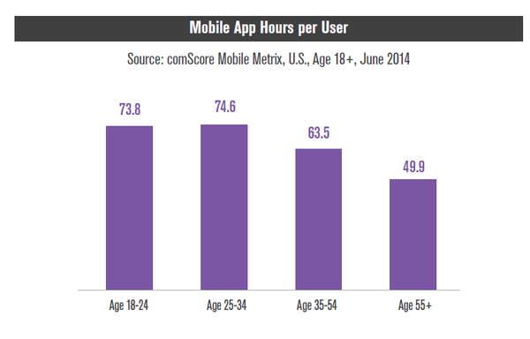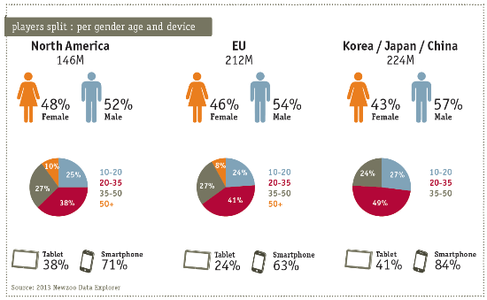**The Target Demographic/ Audience of mobile based app games**

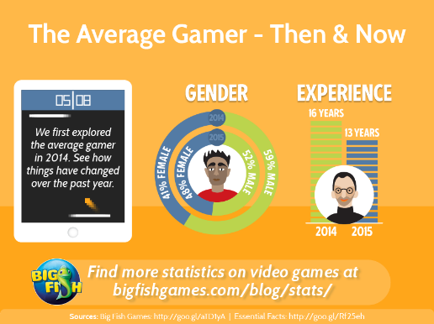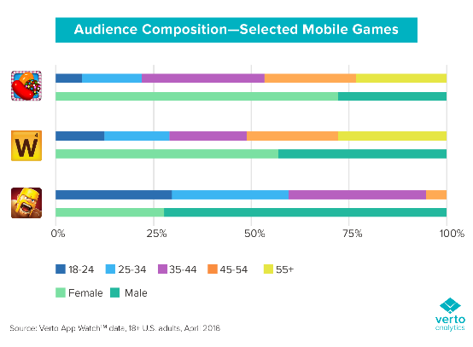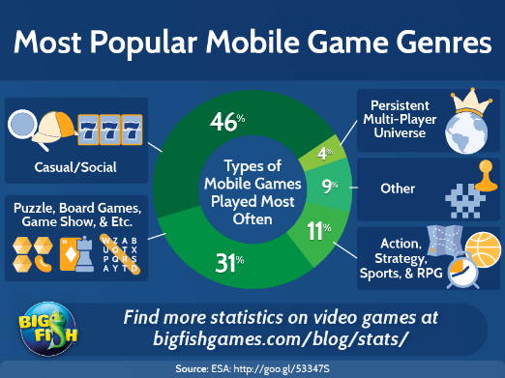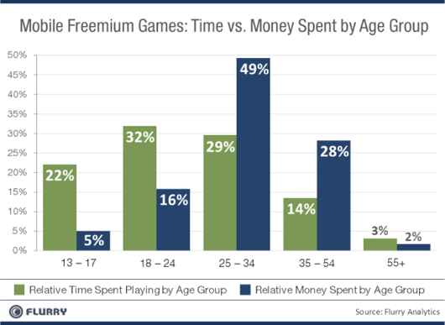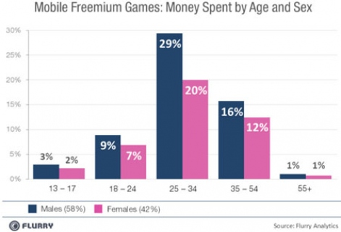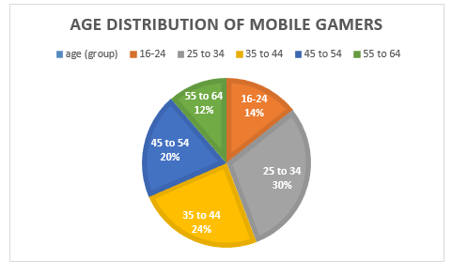

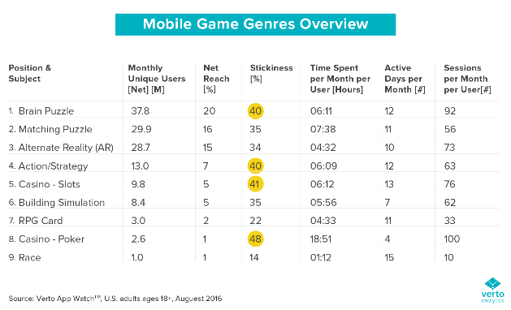

Gathered information from images above

* Women like games that are leaning towards puzzle matching like candy crush saga and men like fighting based games like clash of clans
* 25 to 44 year old male and female mobile gamers have more than half of the mobile gamer market at 54%.
* All across the globe handheld game applications are played more than twice as much on mobiles than they are on tablets or console.
* Male and female gamers aged 25-34 spend a lot more money on freemium games than any other main age group
* Male and female gamers aged 13-17 play games for longer durations of time but do not buy any extras whereas ages 25-34 play less but buy more.
* The most popular mobile game type worldwide with 46% are casual/social games followed by puzzle/ board games at 31%.